(Approx. 830 words)

Musings of an Apple Tyro
By Lorrin R. Garson, Potomac Area Technology and Computer Society
June 2016 issue, PATACS Posts
www.patacs.org
newslettercolumnist (at) patacs.org
Potential Invasion of Privacy
The FTC has warned a dozen app developers against using audio monitoring software from SilverPush. SilverPush, from and Indian company, allows apps to surreptitiously monitor TV viewing habits of people who have downloaded these apps with SilverPush imbedded. These questionable apps are available from the Google Play store. Unfortunately, the apps are not identified. See http://bit.ly/1TUohW5 and http://1.usa.gov/1R3B6Lf for more information.
Millions of Android Devices at Risk
It has been a bad spell for users of Android based devices. Android’s mediaserver and multimedia library, Stagefright, is once again a risk threat. Security problems with Stagefright had been repeatedly reported and patched by Google in 2015. The new threat pertains to devices running Android versions 2.2 through 4.0 and 5.0 and 5.1. Apparently the greatest threat is for Google's Nexus 5 with stock ROM, and with some modifications for HTC's One, LG's G3 and Samsung's S5. See http://bit.ly/1R8T0c2.
ICANN to Rescind Control of the Internet
Until now, ICANN (Internet Corporation for Assigned Names and Numbers (https://www.icann.org) has maintained control of key technical Internet functions. With the international expansion of the Internet, that oversight will likely be turned over to an international body in September 2016. See http://bit.ly/1TQBn6J and http://bit.ly/1PdDRUM. Also see The Economist, March 5, 2016, pp. 55-56.
Troubleshooting Your Printer
Does your printer stop working once in a while? You know, out of paper, empty ink cartridge, paper jam, etc. But beyond the obvious, see http://bit.ly/1Uio12Y for possible solutions to more difficult problems.
Oh So Retro!
Optical storage (CDs, DVDs, Blu-ray, etc.) is quickly fading from home computers. Apple no longer offers optical disk drives in its computers, although you can still buy external drives from Apple. Along comes Sony offering massive Blu-ray drive systems called Everspan (Figure 1) to data centers for archival storage of data that is little changed over time. Everspan can store up to 181 petabytes (1 PB = 1000 TB = 10¹⁵ bytes) of data in a system up to 55 feet in length with hundreds of Blu-ray-like drives. Sony offers a 100-year warranty on the storage medium. With the continuing, rapid change being made in digital storage, it’s hard to imagine this technology will be viable for 10 years, let alone 100 years.

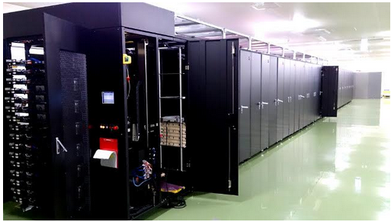
Figure 1

See http://bit.ly/1MaqQRe and http://onforb.es/1R5rxZ1.
Viewing Files in El Capitan
The Finder in OS X El Capitan offers four basic ways to view your files: (1) icon view, (2) list view, (3) column view and (4) cover flow view. Within those four ways there are numerous ways to arrange those files. It can be a bit confusing. However, it may be worthwhile learning more about this topic. See http://bit.ly/1R02qtW.
Easy Access to a Folder
Is there a folder (directory) you frequently access that’s buried deep within a file structure? For example, I have a folder called “Apple--Information” that I frequently access. It’s three levels down from my “Documents” file. You can easily write an AppleScript that will take you directly to such a folder. Here’s how you do it:
- Go to the “Utilities” folder and double-click on “Script Editor.app”.
- Be sure “AppleScript” is selected near the top left of the window displayed, not “JavaScript”.
- Key in the four lines shown in Figure 2 starting with “tell application “Finder”.
- Left-click on the “hammer” icon to compile the script.
- Left-click on the “triangle” icon next to the “hammer” to run the script.
- If you wrote the script correctly… there you are!
- On the menu of “Script Editor” at the top of the desktop, select “File” then ”Save”. When prompted, name the file something meaningful and save it to the Desktop, or wherever you think appropriate.

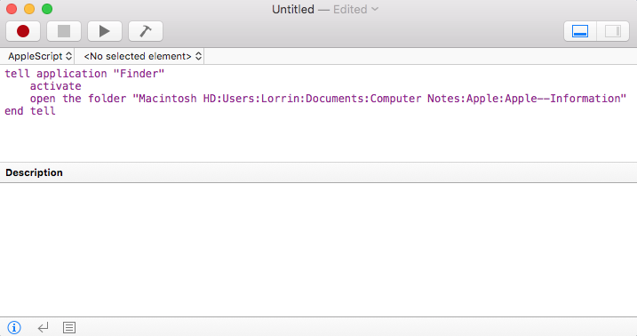
Figure 2
From this point on whenever you want to access that remote folder, double-click on the named, saved script and left-click on the “triangle” icon next to the “hammer”.
You now know how to program a computer! You can do many more things with AppleScript by just writing a set of instructions. To be truthful, it isn’t quite that easy, but AppleScript is a simple “baby” computer language unique to Apple computers. There are numerous books written on how to use it.
The Future of Computing
The Economist (March 12-18, 2016, p. 44ff.) has an excellent article entitled “After Moore’s Law: Double, Double, Toil and Trouble”. As implied by the title, it’s about Moore’s Law slowing down—taking more than two years to double the power of computer chips. It’s an interesting read.

Obviously, you would use the name of your hard disk, your user name, and the folder you wish to access with each level of folders separated by a colon. The example here is specific to the file structure on my iMac. If you want to also open another folder, put in another line “open the folder…”

